Project Proposal for Speed Hero Game Design

# Jonah Trevor-Deutsch #

# Qiyang Xia #

# Jose A Santoyo #100815880

# Supervisor: Cheryl Scharmm

Introduction:

The intention of this proposal is to bring attention to the implementation and development of a system called Speed Hero. Which is part of course program SYSC 3010 Computer systems development Project at Carleton University. More details about Speed Hero game design will be presented below.

Objectives

The objective of this project is to implement a system that consist on three Raspberry Pi (RPi) micro-controllers communicating via UDP/IP Protocol. Based on a Client/Server model, Server(first RPi) will provide a combination series to Clients(second and third RPis ) and the user will then try and input the combination provided as fast as possible. Both results are going to be send back to the Server and this will somehow notify the verdict.

Procedure

It is thought that the implementation would be done using a high level programming language, preferably Python. However the first step is to get familiar with the RPi and its hardware Interfaces (Pi Face & Gertboard); second step is to

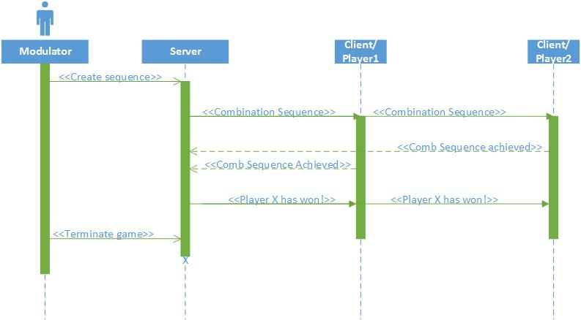

Figure1: Sequence Diagrama